Utilitarian Distribution of Scarce Surgical Capacity During the COVID-19 Crisis and Beyond: A Modelling Study

Benjamin Gravesteijn* (0000-0001-8096-5803)1,2, Eline Krijkamp* (0000-0003-3970-2206)3,5, Jan Busschbach (0000-0002-8602-0381)4,5, Geert Geleijnse (0000-0002-4718-0032)1, Isabel Retel Helmrich (0000-0001-5257-395X)2, Sophie Bruinsma (0000-0003-3634-9899)6, Céline van Lint (0000-0002-7929-7622)6, Ernest van Veen (0000-0002-5495-3996)2,7, Kees Verhoef ([0000-0001-9980-8613](https://orcid.org/0000-0001-9980-8613))8, Jan van Saase (0000-0003-2874-6667)9, Hester Lingsma (0000-0003-2063-9533)2, Rob Baatenburg de Jong (0000-0001-7236-264X)1, and the Value Based OR team collaborators**

*Both authors contributed equally

Author affiliations - Request all authors to check the affiliation + ORCID ID

1) Department of Otorhinolaryngology (ENT); 2) Department of Public Health; 3) Department of Epidemiology; 4) Department of Medical Psychology; 5) Netherlands Institute for Health Sciences; 6) Department of Quality and Patient Care; 7) Department of Intensive Care; 8) Department of surgical oncology and gastrointestinal surgery; 9) Department of Internal Medicine - Erasmus University Medical Center, Rotterdam, the Netherlands.

** Value Based OR team collaborators: Chris Bangma, Ivo Beetz, Patrick Bindels, Alexandra Brandt-Kerkhof, Danielle van Diepen, Clemens Dirven, Tjebbe Galema, Jeanette Goudzwaard, Mieke Hazes, Sjoerd Lagarde, Harmke Polinder-Bos, Eva Maria Roes, Hanneke Takkenberg, Mark van Vledder

Intention to be submitted to:

1. NEJM (advice to try the COVID-19 special, because NEJM is not that into decision models - maybe for COVID they are) How about we also talk about “1. Emanuel EJ, Persad G, Upshur R, et al. Fair Allocation of Scarce Medical Resources in the Time of Covid-19. N Engl J Med 2020;1–7.” in the cover letter
2. Lancet
3. BMJ

# Abstract

## Background

COVID-19 has put unprecedented pressure on healthcare systems worldwide, leading to a reduction of the available healthcare capacity. Consequently, the number of patients waiting for vital surgeries is accumulating and societies face dilemmas about patient prioritization. Our objective was to estimate the effects of non-emergency surgery delay on long-term survival and quality of life using a decision model that can be used for prioritization across disciplines.

Methods

A cohort state-transition model was developed and applied to 34 semi-elective (ideally performed within 3 weeks) surgeries for adults commonly performed in academic hospitals. We compared scenarios of delaying surgery from two weeks up to one year (with 10-week intervals) and no surgery at all. Model parameters were based on national and American registries, literature, and the World Health Organization global burden of disease study. For each surgery, we estimated the average expected Quality-Adjusted Life-Years (QALYs) per scenarios of delay. Urgency was defined as expected health loss due to surgical delay, expressed in QALY loss/month.

## Results

The tree most urgent surgeries were surgically repairing an abdominal aorta aneurysm (0.11 QALY loss/month, 95% CI: 0.09 - 0.13), pacemaker implantation (0.11, 95% CI: 0.04 - 0.22), and peri-hilar cholangiocarcinoma resection (0.09, 95% CI: 0.06 - 0.12). The three least urgent surgeries were placing a shunt for dialysis (0.01, 95% CI: 0.005 - 0.01), resecting thyroid carcinoma (0.01, 95% CI: 0.01 - 0.02), and resecting mild salivary gland carcinoma (0.01, 95% CI: 0.01 - 0.03).

## Conclusion

Expected health loss due to surgical delay can be quantified with our decision model and can guide prioritization of surgical care to minimize population health loss in times of scarcity. Placing this tool in the context of different ethical perspectives and combining it with capacity management tools is key to achieve large-scale implementation.

## Background

COVID-19 has put unprecedented pressure on healthcare systems worldwide. The healthcare demand of the pandemic supersedes total usual healthcare capacity, far beyond the demand that was imposed by the 2017 influenza pandemic.1,2 This pressure on the available healthcare capacity impacts the continuity of regular care.

We can identify multiple causes of the disruption of regular care. At first, because wards and operating theaters are converted to COVID-19 care facilities, fewer non-COVID-19 patients can get surgery.3 Second, because physicians are deployed to care for COVID-19 patients, fewer patients are seen and referred.4,5In the Netherlands, we observed a 90% decrease in referrals during the first part of the crisis compared to previous years.6 Finally, fear of the virus may leave sick people reluctant to seek the care they need 4,5, as was seen in similar health crises like the SARS epidemic.7

Delay in surgical care may impose complex healthcare problems. In the first phase of the COVID-19 crisis in the Netherlands, 75-90% fewer surgeries were performed compared to previous years.6 The impact on healthcare logistics of these delays can be substantial. A modeling study evaluated the consequences of delay of orthopedic surgeries in the United States. They showed that it would take 7-16 months for the system to recover back to nearly full capacity of performing elective surgeries in case they resume elective orthopedic surgery in June 2020.8 This illustration in orthopedic surgery is likely relevant for most vital surgeries. Because an accumulating group of patients is waiting for surgeries, our society is facing dilemmas about which patients should be prioritized.

Experts in the field of medical ethics recently proposed that the distribution of scarce (surgical) resources can be evaluated by the following four ethical values: 1) The scarce resources are used to maximize the benefits; 2) People are treated equally; 3) Instrumental value is promoted and rewarded; 4) The worst off (sickest or youngest) are prioritized.2 In the context of a pandemic, it is justifiable to focus on maximizing the benefits (ethical value 1).9–13 This is consistent with utilitarian ethical perspectives, which emphasize population outcomes over individual outcomes.14

As stated by Emanuel et al., “*The question is not whether to set priorities, but how to do so ethically and consistently, rather than basing decisions on individual institutions’ approaches or a clinician’s intuition in the heat of the moment*”.2 In reality, however, surgical patients are most often triaged by experts from the respective surgical fields,15 while it is known that the agreement of prioritization is low.16 Additionally, prioritization across different disciplines is complicated by the high degree of specialization in modern medicine.

This study aims to develop a decision model to estimate the impact of postponing surgery on health to guide prioritization of surgeries across disciplines from a utilitarian perspective. Although this strategy was conceived during the COVID-19 pandemic, our secondary aim is to ensure applicability to the context of upcoming pandemics, possibly even to the context of regular care and economical scarcity.

## Methods

In short, we selected surgeries most relevant to our setting, and obtained input parameters for the model for these surgeries, and used these parameters in a broadly applicable Markov model to estimate the effect of delaying surgery on survival and health related quality of life (QoL).

### Patients and setting

The evaluated surgeries in this study comprised of non-pediatric and non-obstetric, semi-elective surgeries in Erasmus University Medical Center, an academic tertiary referring hospital in the Netherlands. A semi-elective surgery was defined as not necessarily performed within 3 days, but ideally performed within 3 weeks. We retrieved the number of semi-elective surgeries, surgery time, length of stay at an intensive care unit (ICU), and length of stay at a non-ICU of all non-urgent surgeries from July 2017 to December 2019 from the electronic patient registry (ChipSoft, HiX). The retrieved surgeries were consecutively classified as a semi-elective surgery by two senior clinicians (JvS – emeritus professor internal medicine, RBdJ – head of the department of head and neck surgery). Finally, this selection was checked by the Value Based operation room (OR) team collaborators. Ultimately, 49 semi-elective surgeries were selected that were performed more than 80 times during the inclusion interval. Where relevant, we distinguished mild and severe cases undergoing the surgery. We aimed to collect data about the patient populations with an indication of one of the 49 selected non-pediatric and non-obstetric semi-elective surgery.

### Input parameters

The model required 5 input parameters: survival rates pre- and post-surgery, QoL pre- and post-surgery, mean age of patients undergoing the surgery and time until no effect of treatment can be expected anymore on survival or QoL. An overview of all parameter values and their sources can be found in Appendix A.

The survival data with treatment was obtained from national registries for oncological17 and cardiothoracic18 surgeries, and from literature for the other surgeries. The survival data without treatment for all surgeries is based on data from published studies. If either survival with or without treatment was lacking, the reported treatment effect (preferably from a randomized controlled trial) was used to calculate the missing survival parameter. The disease specific mortality was added to the overall age-specific background mortality from the Central Bureau of Statistics in the Netherlands.19 The mean age of the patients was obtained from published studies. All survival data had to be converted to mortality risk per week (formulas presented in Appendix C).20

The QoL before and after surgery were based on ‘disutility weights’ from the Global Burden of Disease Study 2016 (GBD).21 This study reports disability weights for nonfatal health conditions. These weights represent the magnitude of health loss associated with the conditions, where 0 represents no loss, full health, and 1 all lost, death. When these weights are multiplied with the duration lived in this conditions, one has calculated the weighted ‘years lived with disability’ (YLD).22 The YLD summed with the years of life lost to premature death (YLLs) give the disability adjusted life years (DALY).23 A ‘full DALY’ can be thought of as losing one year in full health. Disability Adjusted Life Years (DALYS) are the complement (the opposite) of the Quality Adjusted Life Years (QALYs), which represents the value of a year spent in full health. For our study, the complement (1-x) of the disability weight was used as QoL values to calculate QALYs.

Where possible, we based the QoL of health conditions directly on the GBD study data. The remaining condition, were estimated using methods described by Stouthard et al.24 We used a visual analogue scale (VAS) calibrated with GBD 2016 QoL weights. Stouthard et al. describe how experts can then place (map) the remaining health conditions on the VAS scale with QoL weights. The only deviation from that protocol was that we did not first classify the health conditions on the EQ-5D. The expert panel consisted of a diverse group of healthcare professionals, both surgeons (e.g. cardiothoracic surgeons, neurosurgeons, and gynecologic surgeons) as well as generalists (e.g. internists, geriatricians and GPs). The health conditions were valued one by one using the following procedure. First, the health condition was shortly introduced by an expert with the most experience about this condition. The other experts were allowed to ask questions and discuss the QoL aspects of the condition. Two to three other experts were then invited to express their estimated QoL value for the health condition. After some discussion, all experts wrote down their own estimation of the QoL value. In this way, the expert could use a maximum of information and opinions, but still express their own estimation. In addition, we could estimate the variance of the values. The mean and 95% confidence interval of the mapped QoL scores were used in the model. We used two session of three hours to collect all QoL value. Eight health states were estimated in both sessions, which allows us to get an indication of the reliability (test-retest by means of a t-test) of the valuations. For the model, the estimates of the first session were used. Appendix D provides the calibrated VAS as well as an overview of the expert panel.

Since postponing surgery can have consequences on the effectiveness of the surgery, we included a model parameter that reflected the time until no effect can be expected of treatment on survival. In practice, this means that when this time has passed, we assumed that the surgery did not have any effect on the survival of the patient anymore. This time is often important in oncological surgeries, where after a specific time a tumor becomes inoperable. The data for parameter came from literature (Appendix A). For most surgeries, only data about the minimal delay not associated with worse survival was evaluated in the literature. For those surgeries, we assumed the upper limit of this parameter to be a year (the maximum delay we evaluated), and the mean of the lower and upper limit as average. The same was done for the time until no effect can be expected on QoL.

### Markov model

To quantify the long-term health effects of surgery delay we made use of a Markov cohort state-transition model (cSTM). This model type is frequently used in clinical decision analysis, because it is relatively simple to build, easy to communicate and can synthesize data from different sources to estimate long-term outcomes.25,26 A cSTM simulates a hypothetical cohort of patients over a defined period in fixed time intervals, called cycles, to estimate the average time individuals spend in the various health conditions, called health states.20,25 Based on the time spent in these states, health benefits, like expected life years or QALYs are calculated.20,27

For our aim, we developed a three-state cSTM with a preoperative state, a postoperative state, and a dead state (Figure 1). The entire cohort starts in the preoperative state, and was followed their entire remaining lifespan, until they are 100 years old, using weekly cycles. The transition from the preoperative state to the postoperative state was set to a specific week, depending on the scenario. We evaluated scenarios where patients were treated immediately (delay of two weeks) up to a delay of a year using intervals of ten weeks. In addition, we evaluated the scenario where nobody ever received treatment: this was modeled by following patients their remaining lifespan in the preoperative health state. In all scenarios, the transitions from the pre- and postoperative states to the absorbing state dead were based on survival data. If the delay was longer than the time until no effect of surgery on survival or QoL, the postoperative survival and QoL were set equal to the preoperative survival.

### Analysis

Probabilistic sensitivity analysis was used to incorporate parameter uncertainty in the model outcome. Instead of simulating all scenarios with a fixed parameter estimate, we simulated all scenarios with 100 parameter sets. These parameters sets were drawn from the distribution that best described these parameters. We used triangle distributions for the survival probabilities, the time to no effect on survival or QoL, and QoL; we used lognormal distributions for relative treatment effects; and normal distributions for age. The 50th, 2.5th, and 97.5th percentile of these PSA estimates were calculated, which correspond to the main estimate and the lower and upper limit of the 95% confidence interval, respectively. To calculate QALY loss due to delay, the QALYs associated with delaying surgery for 52 weeks was subtracted from the QALYs associated with delaying the surgery for 2 weeks. This gives the QALY loss per 50 weeks, which in turn was converted to QALY loss per month. Rankings based on different model outputs were compared using Spearman’s rank correlation coefficient.

### Model output

The output of the model comprises of life years (LY) and QALYs. By subtracting the (QA)LYs of surgery at 2 weeks by the (QA)LYs of no surgery at all, we calculate the (QA)LYs associated with surgery. By subtracting the (QA)LYs of surgery at 2 weeks by the (QA)LYs of surgery at a year, we obtain the (QA)LYs loss per 50 weeks. This measure of urgency is converted to loss per month. This is the measure used to rank the surgeries. Finally, the model results were visually compared to the capacity requirements, obtained from the electronic patient registry.

### Assumptions

The design of the model translates to the following core assumptions:

* The health benefit of the surgery for the average patient is evaluated.
* The model does not include complications or a period of recovery, both of which can reduce QoL temporarily.
* Surgeries are successful: no increased risk of mortality during surgery is assumed.
* The COVID-19 context does not impact the performance of the surgeries.

The output of the model should therefore be interpreted as the maximum health gain associated by performing the surgery successfully for an average patient, in an OR-setting not complicated by COVID-19. We assume that complications and harm associated with surgery do not differ between various delays. Therefore, the measures of urgency, QALY and LY loss per month, can be compared across treatments with varying associated harm.

Because benefits now are enjoyed more that in the distant future, it is recommended to perform discounting.28,29 A discount rate of 0.015 per year for health benefits was used, as this is common practice in the Netherlands.29 Discounting makes current benefits worth more than those expected in the future. If discounting is not performed, we would value health gains achieved this year equal to those achieved in 30 or 40 years.

This manuscript is guided by the CHEER guidelines for reporting health-economical evaluations.30 The model was built in R software31 and the code is based on tutorials provided by the DARTH workgroup.32,33 The model code and input data are freely available via a GitHub repository: [ADD LINK IF JOURNAL AGREES].

# Results

We evaluated 8 cardiothoracic surgeries, 19 oncological surgeries, 2 transplantations (liver and living donor kidney), 4 vascular surgeries, and 1 other type of surgery (creation of a shunt to facilitate hemodialysis). These 34 evaluated surgeries comprised of 49% of the total semi-elective program in our hospital.

For all surgeries, survival with treatment could be obtained. For 13/34 surgeries, survival without treatment could be directly obtained. For 21/34 surgeries, survival without treatment was calculated from the treatment effect and the survival with treatment. For 14 surgeries, QoL was available through the WHO Global Burden of Disease study. For the remaining 20 surgeries, the QoL of the pre- and postoperative health state was estimated by the expert panel as described in the methods section. For none of the surgeries a “time-to-no-effect-on-QoL” within one year, our maximum period of delaying surgery, was found.

For 16 surgeries, we assumed a “time-to-no-effect-of-treatment-on-survival”. All these surgeries were oncological surgeries. Input parameters varied widely between surgeries (Figure 2). All input parameters, their source17,18,42–51,34,52–61,35,62–71,36,72–81,37,82,38–41, and the corresponding model output for every surgery are presented in Appendix A.

The QoL of eight health states were estimated in the both sessions with the expert panel. The absolute QoL of these health states was estimated significantly higher in the second session (the standardized mean difference was 0.07, 95% CI: 0.02 – 0.11). However, the gain in QoL due to surgery was not estimated significantly higher or lower in the second session (the standardized mean difference was 0.025, 95% CI: -0.11 – 0.16, table 3 and figure 1 Appendix B).

The maximum expected benefit, i.e. in a scenario without delay and no harm from surgery, from the evaluated surgeries ranged from 0.54 QALYs (95% CI: 0.48 - 0.61) for resection of high-grade glioma to 10.3 QALYs (95% CI: 8.7 - 11.9) for kidney transplantation (Figure 3). The ranking based on QALYs gained by surgery was moderately correlated with the ranking based on LYs gained by surgery:the Spearman rank correlation coefficient between the ranking of surgeries based on LYs and QALYs was 0.35 (p=0.045).

The urgency of the surgeries ranged from 0.01 QALY loss/month (95% CI: 0.00 - 0.01) for placing a shunt for dialysis, to 0.11 QALY loss/month (0.09 - 0.13) for the surgical repair of an abdominal aneurysm of the aorta (Figure 4, and table 1 Appendix B). Surgeries that were associated with a high expected QALY benefit by surgery, did not always lose more QALYs per month as well: The Spearman correlation coefficient between the ranking of health benefit, in terms of QALYs, and urgency, in terms of QALY loss per month, was 0.31 (p=0.07). The most urgent surgeries after surgical repair of an abdominal aneurysm of the aorta were pacemaker implantation (0.11 QALY loss/month, 95% CI: 0.04 - 0.22), and resection of cholangiocarcinoma (0.09 QALY loss/month, 95% CI: 0.06 - 0.12). After placing a shunt for patients with end-stage renal disease, the least urgent surgeries were resection of thyroid cancer (0.01 QALY loss/month, 95% CI:0.01 - 0.02) and the resection of mild salivary gland carcinoma (0.01 QALY loss/month, 95% CI: 0.01 - 0.03) (Appendix B). When ordering surgeries based on LYs lost per month instead of QALYs lost per month, resection of non-small cell lung carcinoma was ranked substantially lower (from rank 5 to rank 19), while the implantation of a left-ventricle assist device was ranked substantially higher (from rank 8 to rank 1).

Surgeries that are ranked high in terms of urgency and had relative short surgery time include repair of atrial septum defects (surgery time: 74 min [IQR: 56-131], urgency: 0.06 QALY loss/month [95% CI: 0.02 – 0.14]), pacemaker implantations (115 min [82-154], 0.11 QALY loss/month [0.04 - 0.22]), and resection of mild larynx carcinoma (70 min [38 – 109], 0.07 QALY loss/month[0.05 - 0.11]) (Figure 5). Liver transplant is relatively urgent, but requires an exceptional amount of OR-time (875 min [797 - 957], 0.08 QALY loss/month [0.07 - 0.09]) (table 2 Appendix B).

# Discussion

Our decision model can be used to guide prioritization of surgeries from a utilitarian perspective, by quantifying urgency based on the expected health loss due to surgery delay. Our results demonstrate that we can rank semi-elective surgeries based on their urgency using a simple three-states Markov cSTM. Using this approach, we found that among the surgeries we analyzed, repairing an abdominal aneurysm of the aorta, implantation of a pacemaker, and the resection of cholangiocarcinoma were the most urgent surgeries. Less urgent surgeries were installment of a shunt for dialysis, resection of thyroid cancer, and the resection of mild salivary gland carcinoma. Liver transplantation shows to be a relatively urgent surgery, but requires an exceptionally long surgery time. In times of scare OR-capacity this makes this surgery less efficient in the prevention of QALY loss when aiming for the most health on a population level.

We propose to use the loss of QALY per unit time delay of surgery as a measure of urgency. This strategy is an alternative to the currently most employed approach: triaging by expert teams from the respective surgical fields.15 Because experts weigh each objective characteristic by their own personal values, the agreement in prioritization is low.16 Moreover, prioritization across different disciplines is complicated by the high degree of specialization in modern medicine. Finally, this approach is not objective nor transparent, and conflicts of interests at the individual and departmental level may arise. Therefore, we feel our approach is more objective, transparent, and evidence-based, while operationalizing ethical values that are the most appropriate in times of scarcity.2

To illustrate what this measure actually represents, we take the most urgent surgery, surgically repairing an abdominal aneurysm of the aorta, as an example. Surgically repairing an abdominal aneurysm of the aorta is associated with a QALY loss of 0.11 per month –partly due to the prospect of a potentially life-threatening rupture preoperatively, partly due to the increase in survival after surgery. This implies that if this surgery would be postponed by a month, patients with this surgical indication lose approximately 40 days (0.11*365) spent in perfect health of their remaining expected QALYs gained by surgery. Although the personal value of a loss of 40 days spent in perfect health can be different for everybody, it is a substantial loss compared to the least urgent surgery: a similar calculation for the placing of a shunt for dialysis is associated with 4 days less spent in perfect health by delaying the surgery by a month.

Interestingly, the ranking of urgency is primarily driven by the gain in life years associated with surgery. Surgeries that are associated with substantial gain in life years (e.g. repair of an abdominal aneurysm of the aorta), also lose more QALYs per month delay than surgeries that are associated with no gain in life years (e.g. creation of a shunt for hemodialysis). The larger the total health benefit associated with surgery, the more can potentially be lost by postponing.

Nevertheless, QoL is important to include, because it substantially impacts urgency of some surgeries. Implantation of a left-ventricle assist device (LVAD) ranked first in terms of urgency if QoL was not taken into account. The absolute preoperative and postoperative QoL values are quite low for this surgery (0.30 and 0.67 respectively): although the functionality of patients may improve substantially after implantation of an LVAD, the psychological burden of having one’s life depend on an implanted device impacts QoL significantly.83 By disregarding QoL (setting it to 1), the expected health benefit was much greater, because the surgery is associated with a substantial amount of life years. Therefore, there was much more to lose by postponing surgery. In contrast, non-small cell lung carcinoma was ranked much lower when QoL was not included. The preoperative and postoperative quality of life differed substantially (0.56 and 0.95, respectively), because symptoms of the tumor (e.g. coughing blood) and the burden of suffering from lung cancer significantly impact QoL.84 These symptoms and this burden may often be lifted postoperatively. Their life expectancy is however limited due to relatively high age (79 years).57 Not taking this large gain in QoL into account resulted in a much lower rank, because the total health benefit decreased. Therefore, there is less health benefit to lose by postponing surgery.

To optimize OR triage, our metric for urgency should be weighed against hospital capacity. Hospital capacity might be interpreted as the costs in times of crisis. For the scenario where OR-capacity is the scarcest hospital capacity, urgency can be plotted against surgery time. This simple method revealed that pacemaker implantation, resection of mild larynx carcinoma, and repair of ASD are the most efficient surgeries in our hospital to perform in this context. However, there are contexts were other types of capacity (e.g. ICU beds, hospital beds) are scarcer, and therefore more relevant to be weighed against urgency. Scarcity might even vary per week, in a dynamic crisis situation such as the COVID-19 pandemic.

Although this approach rationalizes and objectively quantifies urgency from a utilitarian perspective, it needs to be complemented by other perspectives to be used effectively in practice. First, an important consideration from the medical perspective may be the availability of alternative treatment strategies. In cancer treatment, (chemo-)radiation or systematic therapy alone may be considered instead of surgery, even when the effectivity would be lower, since waiting lists may be shorter and no OR or Intensive care unit (ICU) capacity is needed. Second, an important consideration from the logistical perspective might be the impact of surgeries on the hospital capacity, which can differ in different phases of crises (e.g. surgery time is scarce in one week, and ICU capacity in the other). Third, a financial perspective might also be explored. This perspective might be less relevant in a crisis such as the COVID-19 pandemic, where the bottleneck mainly seems hospital capacity in state of costs. If this approach would be applied to the context of regular care, this perspective might be of increasing importance. Finally, other ethical perspectives (e.g. rule of rescue14) might be explored to assess the viability of our approach, and to find the scope of surgeries where our approach is applicable.

There are practical advantages of comparing “average patients” on urgency, despite the fact that there is no such thing as an “average patient”: It prevents our approach from systematically discriminating against a specific group of patients. Our approach would only discriminate if specific socioeconomic groups would suffer more frequently from diseases that are less urgent. It is known that lower socioeconomic groups are more prone to develop cancers that have clear association with unhealthy behavior, such as lung cancer.85 However, these diseases do not systematically rank low in our approach. Comparing the average patients across specialties on urgency may give input for shared decision making: we feel that next to a quantitative estimation of urgency from a utilitarian perspective, individual patient’s preferences, social contexts, and operability should also be included in the decision making process of prioritization.

Since all models are, by definition, a simplification of reality, our model has several limitations. First, we assume that all surgeries are successful. We do not simulate adverse events, like major bleedings or death due to surgery. We also did not incorporate the potential reduction of QoL due to these adverse events or QoL reduction of a temporary period of recovery after surgery. Because of these assumptions, the overall QALYs associated with the surgery should not be interpreted as absolute estimate. They can be considered the maximum possible QALYs that can be acquired by performing the surgery. However, these assumptions were considered reasonable to achieve the main goal of this study: when surgery without delay is compared to surgery with delay, the harm in both scenarios is similar and therefore cancels out.

Second, we used a linear approximation to quantify urgency by delaying surgery up to a year. Some surgeries did show a slightly steeper decrease in the first phase of delay. We have chosen for this pragmatic approach because we did not specifically design the model to validly estimate the curvature in this descend.

Third, there are methodological issues with the fact that we calculated QALYs by the disutility weights by the WHO. … There are also multiple methodological, ethical, and contextual disadvantages of using QALYs.86

Fourth, we did not include the potential impact on QoL of delaying a semi-elective surgery. This impact might differ across surgeries. It might be hypothesized that surgeries performed after already a long disease history (e.g. kidney transplant) might have less “waiting time disutility” than recently diagnosed diseases (e.g. mammacarcinoma).

Fifth, we found that absolute QoL was estimated higher in the second expert session. However, the relevant measure of QoL in our model is the difference between preoperative and postoperative QoL, which did not differ significantly between the two sessions. Although our estimates remain valid, it might be reasonable to validate our QoL estimates in a larger sample of experts.

The model was tailored to the context in the Netherlands by using the national registry data. However, a substantial amount of the input used in the model originated from various international sources. Therefore, with some modifications, and using international data, the model can easily be applied to different contexts. Moreover, the model could be developed further by also modeling complications, recovery periods and the effect of comorbidity on survival. Therefore, this study can be considered the first step towards a triaging strategy which optimizes surgical benefit in times of scarcity in surgical capacity, such as during the COVID-19 pandemic. The next step is to create sufficient support base for this approach. If successful, a wider range of surgeries should be considered, implementation strategies should be explored and evaluated, and the model should be applied to a variety of settings.

# Conclusion

Our decision model guides prioritization of surgical care in times of scarcity in surgical capacity (due to COVID-19) from a utilitarian perspective. The expected health loss due to delay could be quantified for semi-elective surgeries in our hospital. This observation can help to minimize health losses when trying to overcome delay in surgeries across disciplines. This approach is more transparent, more evidence-based, and more objective than the alternative strategy of triaging based on expert opinion. Placing this tool in the context of different ethical perspectives and combining it with capacity management tools is key to achieve large-scale implementation.

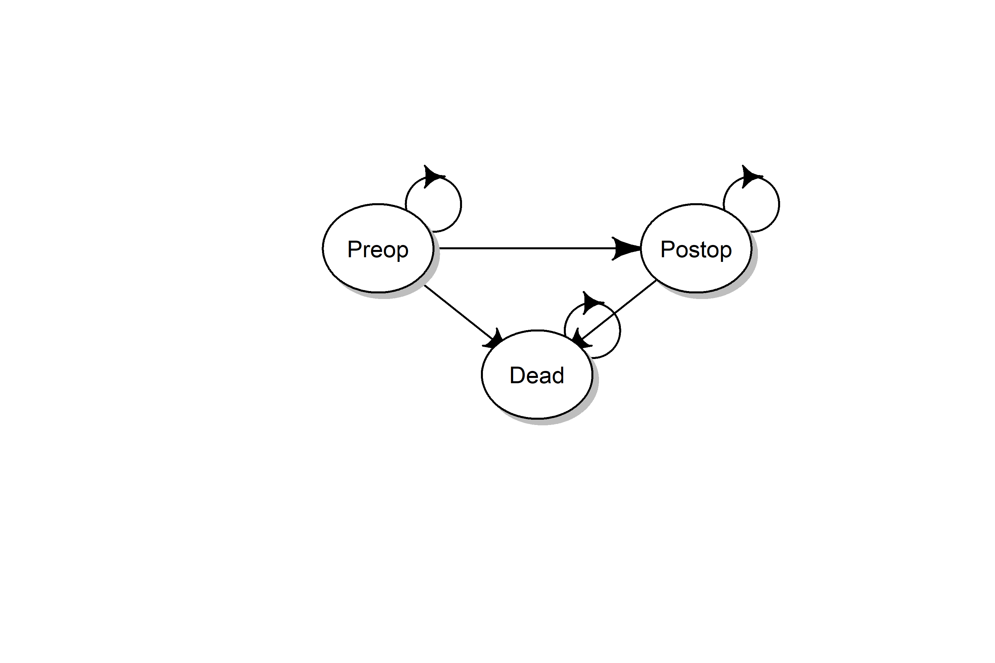

Figure 1, state-transition diagram of the cohort model. The model is a Markov model with three health states, a preoperatieve health states (Preop), a postoperatieve state (Postop) and Dead. All patients start in the Preop health states. This is the health states where patient eligible for surgery start in our simulation. We follow these patients over time using fixed time intervals of 1 week, these fixed time intervals are called cycles. Every cycle, patients can transition to one of the other health states or they can remain in the health states they currently are. From the Preop state they either die (transition to dead state) or continue to wait for their surgery (stay in the Preop state, the arrow points back into the health state). At the time of surgery, which is determined by us, all individuals still alive in the Preop health state transition to the Postop health state. The remaining lifetime the cohort is followed. They can die (transition from the Postop state to Dead state) or stay alive in the Postop health state (transition back to the Postop state). Finally, patients in the Dead state remain dead, so every cycle they stay in the dead state.

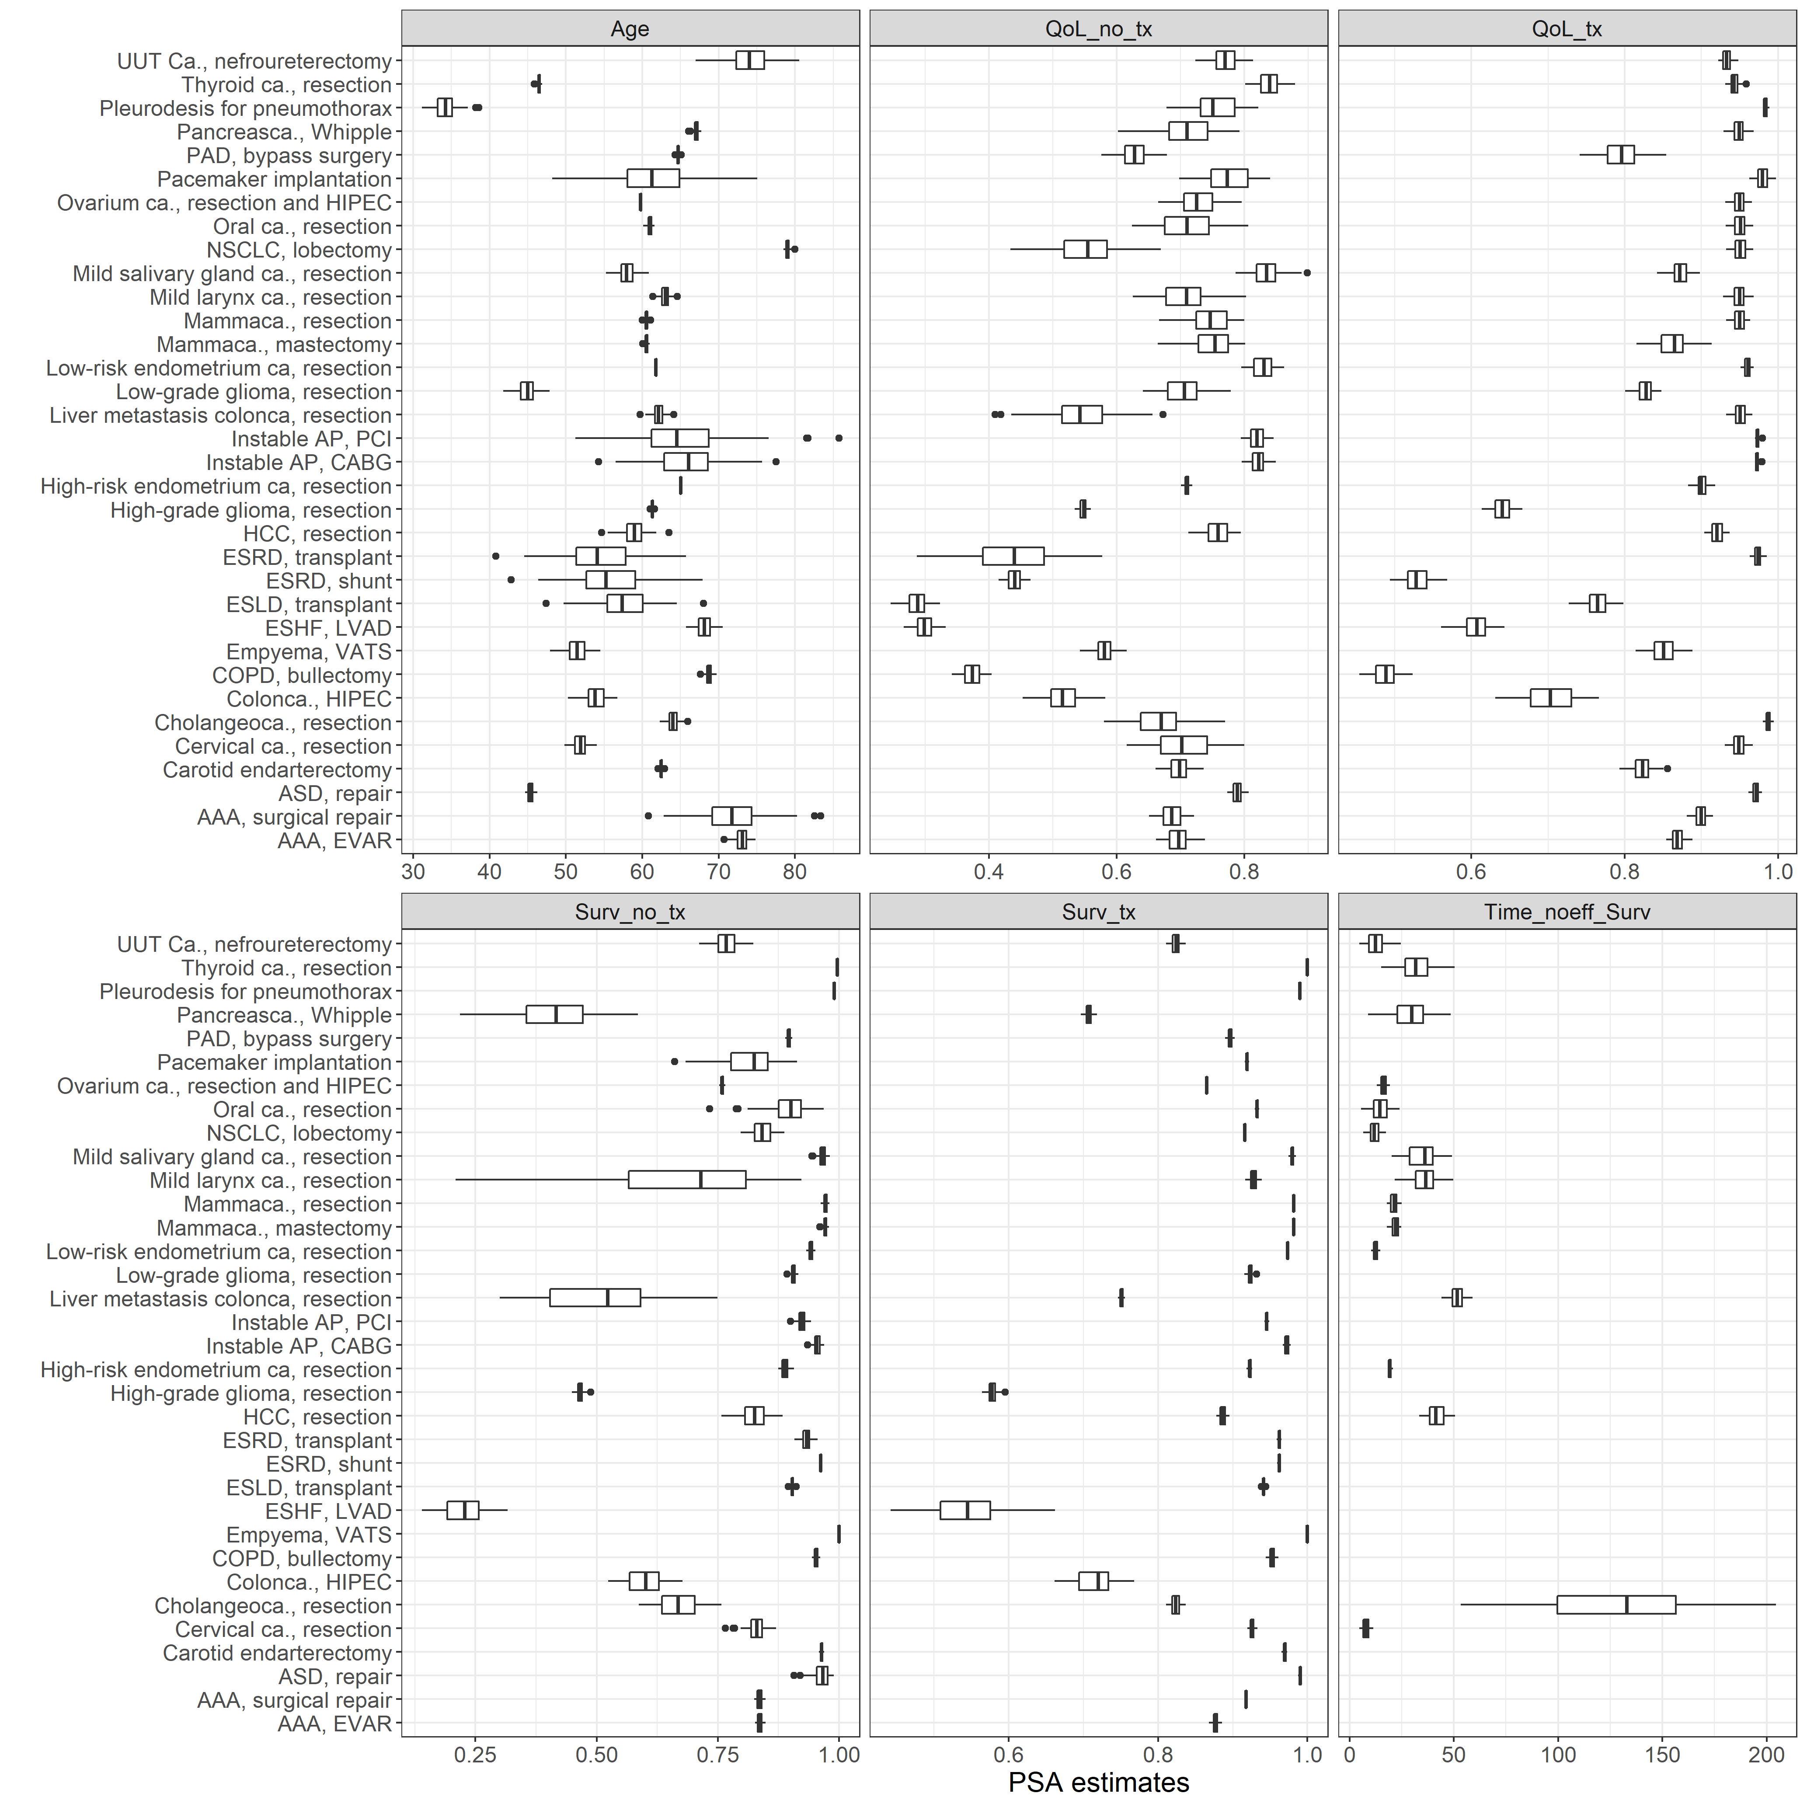

Figure 2, input parameters for the model. For a full list of input parameters per disease and source, see appendix A. **Abbreviations Figure titles**: Qol_no_tx: Quality of Life without treatment; QoL_tx: quality of life with treatment; Surv_no_tx: 1-year survival probability without treatment; Surv_tx: 1-year survival probability with treatment; Time_noeff_surv: days until no treatment is effective. **Abbreviations surgery/indications:** AAA: aneurysm of the abdominal aorta; AP: angina pectoris; ESRD: end-stage renal disease; ASD: atrial septum defect; ca.: carcinoma; CABG: coronary artery bypass graft; ESHF: end-stage heart failure; ESLD: end-stage liver disease; EVAR: endovascular aortic repair; HIPEC: hyperthermic intraperitoneal chemotherapy; HCC: hepatocellular carcinoma; NSCLC: non-small cell lung carcinoma; PAD: peripheral arterial disease; PCI: percutaneous coronary intervention; UUT: upper urinary track; VATS: video assisted thoracoscopic surgery

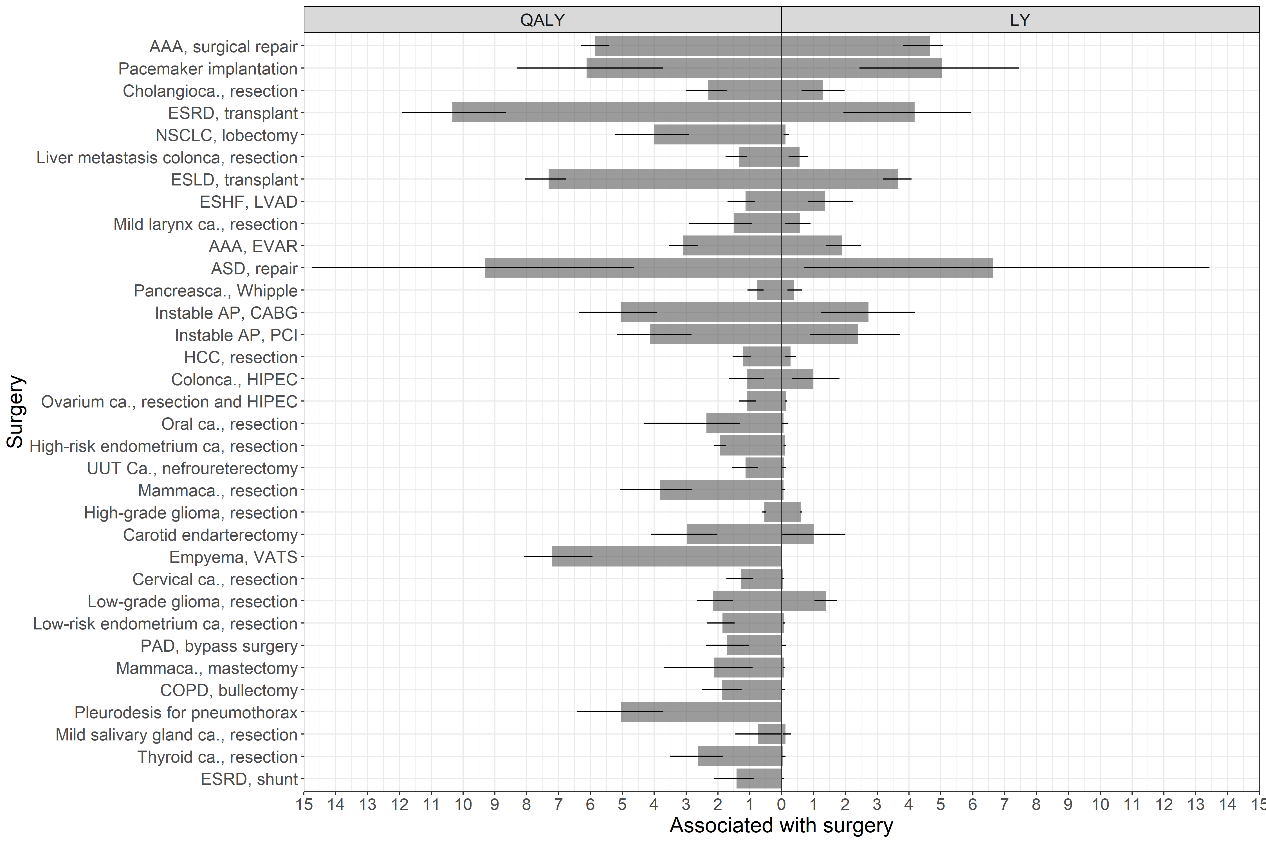

Figure 3, the maximum expected QALYs and LYs per surgery, in descending order of urgency (see figure 4). The estimates (gray bars) and 95% confidence intervals (black lines) are shown. The model output for no surgery was subtracted from the model output for a delay of 2 weeks. The actual data are presented in Appendix B. **Abbreviations Figure titles**: QALY: Quality of Life without treatment; LY: life years. **Abbreviations surgery/indication**: AAA: aneurysm of the abdominal aorta; AP: angina pectoris; ESRD: end-stage renal disease; ASD: atrial septum defect; ca.: carcinoma; CABG: coronary artery bypass graft; ESHF: end-stage heart failure; ESLD: end-stage liver disease; EVAR: endovascular aortic repair; HIPEC: hyperthermic intraperitoneal chemotherapy; HCC: hepatocellular carcinoma; NSCLC: non-small cell lung carcinoma; PAD: peripheral arterial disease; PCI: percutaneous coronary intervention; UUT: upper urinary track; VATS: video assisted thoracoscopic surgery

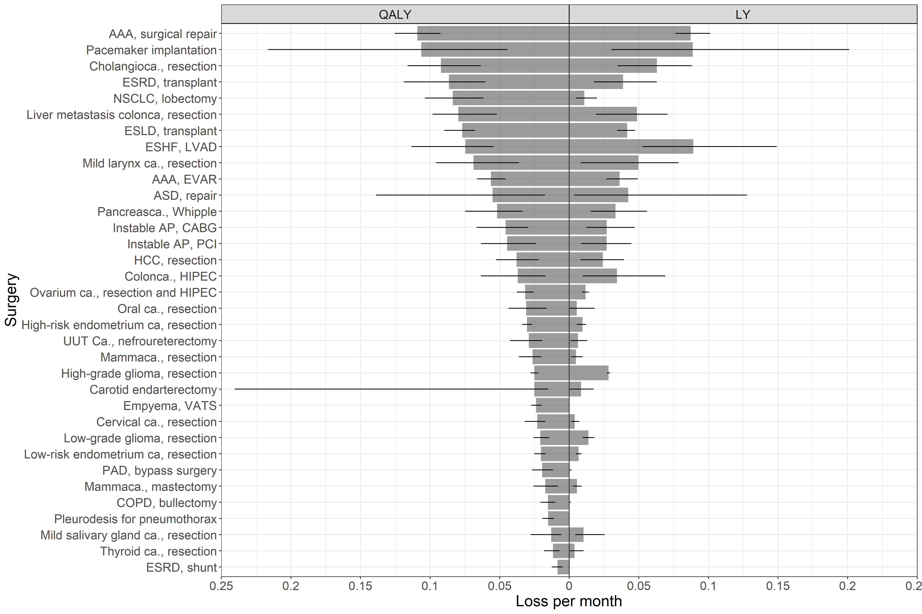

Figure 4, the average loss of QALYs and LYs per month of delay for the investigated surgeries based on the simulation of surgery delay of 52 weeks. The estimates (gray bars) and 95% confidence intervals (black lines) are shown. The actual data are presented in appendix B. **Abbreviations Figure titles**: QALY: Quality of Life without treatment; LY: life years **Disease abbreviations**: AAA: aneurysm of the abdominal aorta; AP: angina pectoris; ESRD: end-stage renal disease; ASD: atrial septum defect; ca.: carcinoma; CABG: coronary artery bypass graft; ESHF: end-stage heart failure; ESLD: end-stage liver disease; EVAR: endovascular aortic repair; HIPEC: hyperthermic intraperitoneal chemotherapy; HCC: hepatocellular carcinoma; NSCLC: non-small cell lung carcinoma; PAD: peripheral arterial disease; PCI: percutaneous coronary intervention; UUT: upper urinary track; VATS: video assisted thoracoscopic surgery

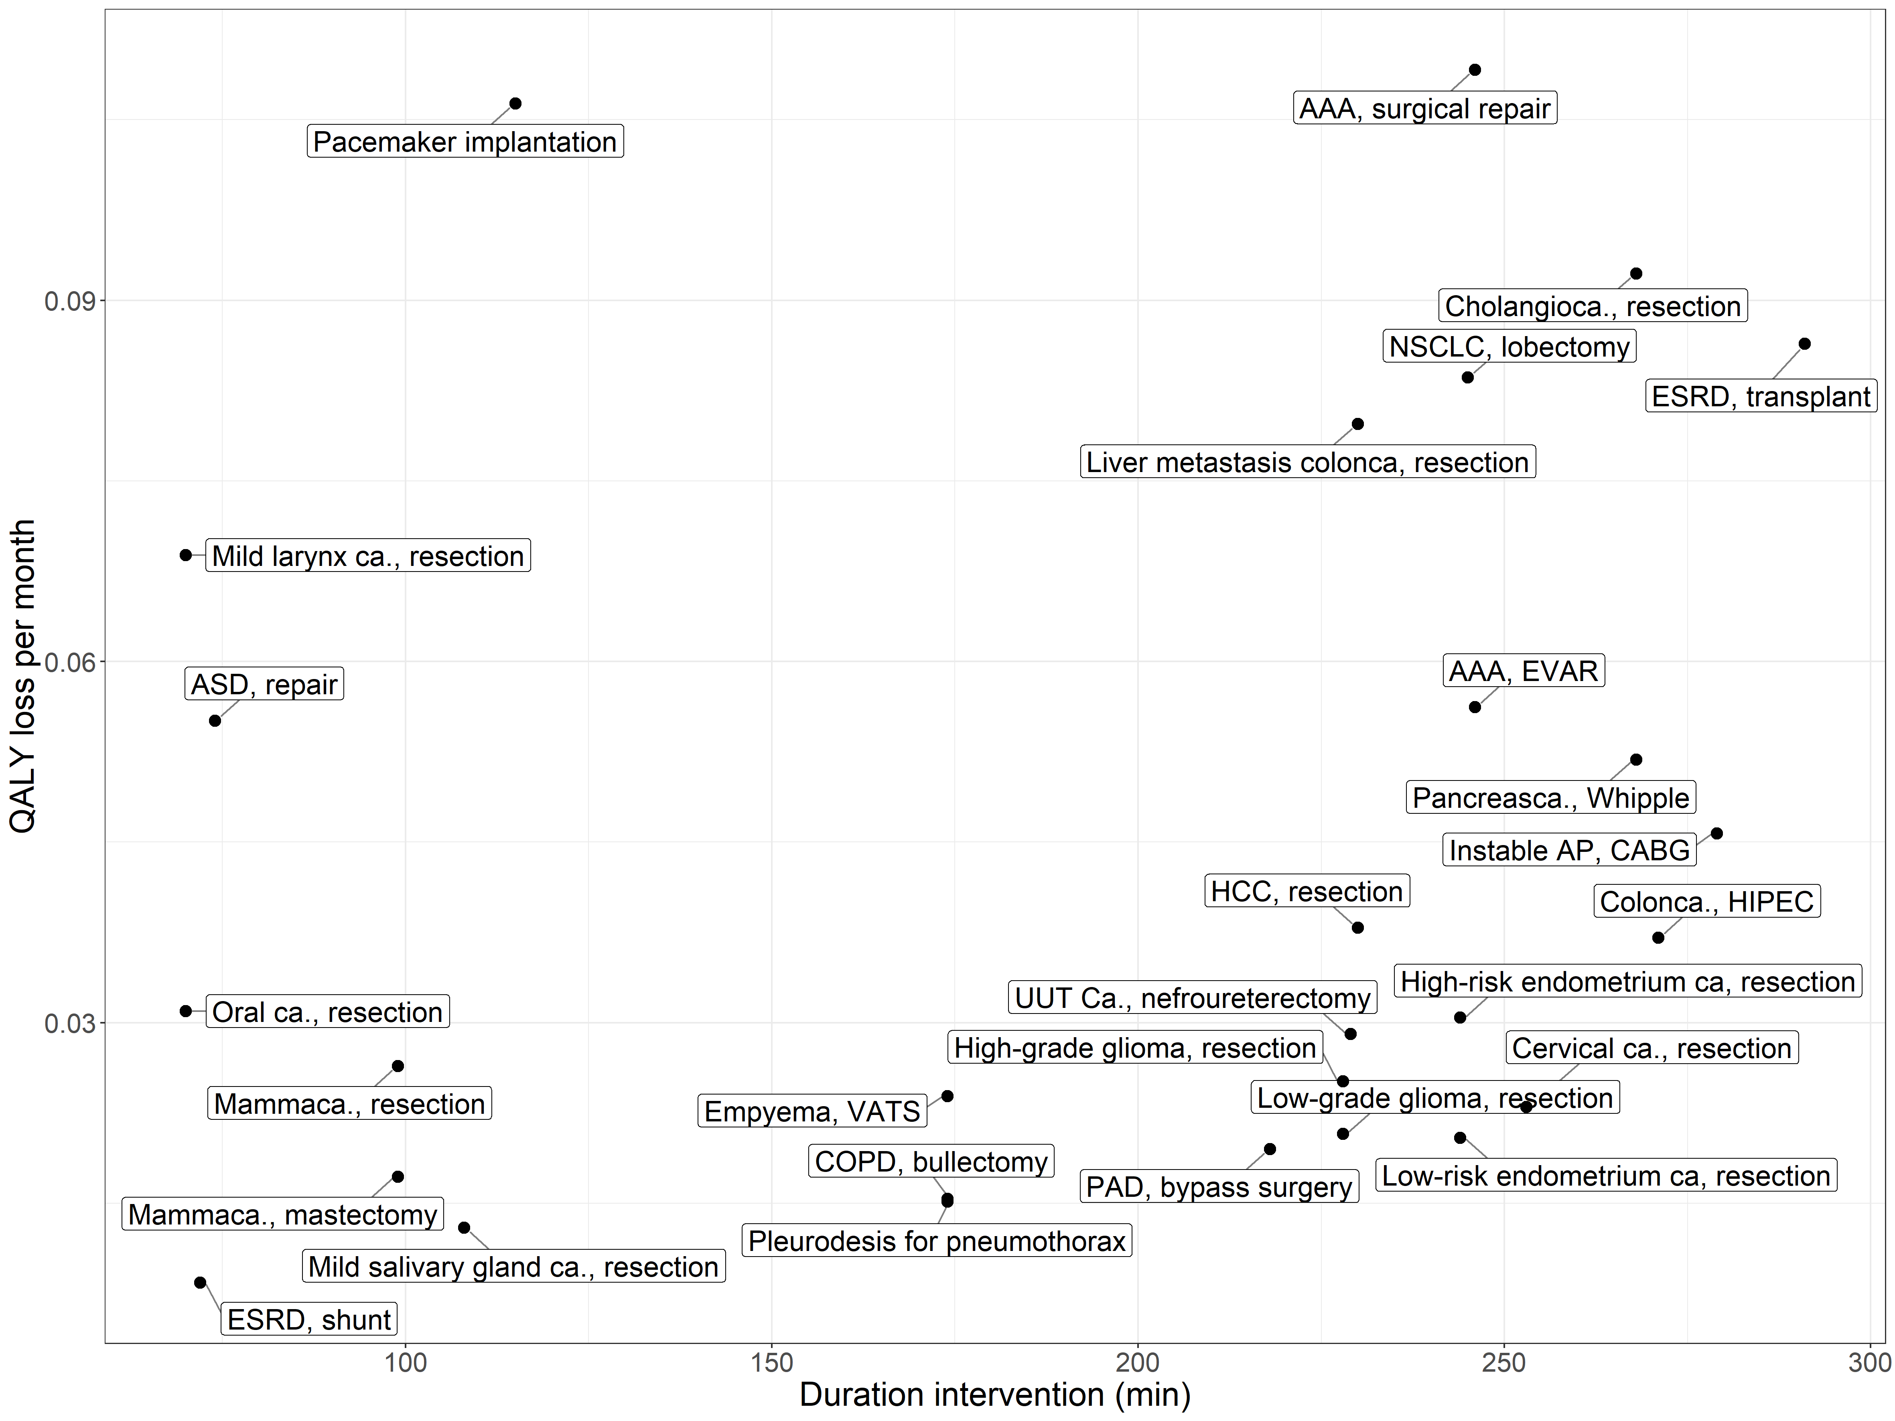

Figure 5, showing the mean duration of the surgeries and the urgency in terms of QALY loss per month. Liver transplant is excluded in this plot, because it was an outlier in terms of duration of surgeries (median: 875 minutes, IQR: 797-957 and -0.08 QALY per month, 95% CI: -0.09 - -0.07). **Abbreviations Figure titles**: QALY: Quality of Life without treatment. **Disease abbreviations**: AAA: aneurysm of the abdominal aorta; AP: angina pectoris; ESRD: end-stage renal disease; ASD: atrial septum defect; ca.: carcinoma; CABG: coronary artery bypass graft; ESHF: end-stage heart failure; ESLD: end-stage liver disease; EVAR: endovascular aortic repair; HIPEC: hyperthermic intraperitoneal chemotherapy; HCC: hepatocellular carcinoma; NSCLC: non-small cell lung carcinoma; PAD: peripheral arterial disease; PCI: percutaneous coronary intervention; UUT: upper urinary track; VATS: video assisted thoracoscopic surgery

Disclosures

**(Please add your personal disclosures!)**

No specific funds were rewarded for this project.

**JVS no personal disclosures**

Acknowledgement **(Please add anyone we have to acknowledge here)**

We are grateful for H. Karreman and C. Van der Velden - van der Graaf for the work they have done for the quality of life data collection. Moreover, we want to thank Ruben Goedhart, Esther van Spronsen and Linda van der Sluijs – van der Beek for extracting the data from the electronic patient registry. We like to thank the support of our research: Isabel Retel Helmrich and Ernest van Veen are supported by the European Union 7th Framework program (Center-TBI, EC grant 602150). Eline Krijkamp is supported by the Society for Medical Decision Making (SMDM) fellowship through a grant by the Gordon and Betty Moore Foundation (GBMF7853).

References

1. Office of the Assistant Secretary for Preparedness H. Pandemic Influenza Plan - Update IV (December 2017). 2017.

2. Emanuel EJ, Persad G, Upshur R, et al. Fair Allocation of Scarce Medical Resources in the Time of Covid-19. N Engl J Med 2020;1–7.

3. D’Agostino A, Demartini B, Cavallotti S, Gambini O. Mental health services in Italy during the COVID-19 outbreak. The Lancet Psychiatry. 2020;7(5):385–7.

4. Lazzerini M, Barbi E, Apicella A, Marchetti F, Cardinale F, Trobia G. Delayed access or provision of care in Italy resulting from fear of COVID-19. Lancet Child Adolesc. Heal. 2020;4(5):e10–1.

5. Harahsheh AS, Dahdah N, Newburger JW, et al. Missed or Delayed Diagnosis of Kawasaki Disease During the 2019 Novel Coronavirus Disease (COVID-19) Pandemic. J Pediatr Pandemic J Pediatr [Internet] 2020 [cited 2020 May 15];Available from: https://doi.org/10.1016/j.jpeds.2020.04.052.

6. NZA. Analyse van de gevolgen van de coronacrisis voor de reguliere zorg [Internet]. 2020 [cited 2020 May 17]. Available from: https://zorgdomein.com/media/documents/NZa-analyse_van_de_gevolgen_van_de_coronacrisis_voor_de_reguliere_zorg_-....pdf

7. Chang H-J, Huang N, Lee C-H, Hsu Y-J, Hsieh C-J, Chou Y-J. The Impact of the SARS Epidemic on the Utilization of Medical Services: SARS and the Fear of SARS. Am J Public Health [Internet] 2004;94(4):562–4. Available from: http://ajph.aphapublications.org/doi/10.2105/AJPH.94.4.562

8. Powell SN, Mullen T, Young L, Heald D, Iv ETP. SARS-CoV-2 Impact on Elective Orthopaedic Surgery: Implications for Post-Pandemic Recovery. J Bone Jt Surg 2020;

9. Vergano M, Bertolini G, Giannini A, et al. Clinical Ethics Recommendations for the Allocation of Intensive Care Treatments in exceptional, resource-limited circumstances [Internet]. 2020 [cited 2020 May 17]. Available from: http://www.siaarti.it/SiteAssets/News/COVID19 - documenti SIAARTI/SIAARTI - Covid-19 - Clinical Ethics Reccomendations.pdf

10. Daugherty Biddison L, Berkowitz KA, Courtney B, et al. Ethical considerations: Care of the critically ill and injured during pandemics and disasters: CHEST consensus statement. Chest 2014;146(4 Suppl):e145S-e155S.

11. Bayer R. Ethical Considerations for Decision Making Regarding Allocation of Mechanical Ventilators during a Severe Influenza Pandemic or Other Public Health Emergency. 2011.

12. York State Department of Health N. VENTILATOR ALLOCATION GUIDELINES New York State Task Force on Life and the Law New York State Department of Health. 2015.

13. Toner E, Waldhorn R. Responding to pandemic influenza - The ethical framework for policy and planning | Information | Health Service Journal [Internet]. 2020 [cited 2020 May 17];Available from: https://www.hsj.co.uk/swine-flu/responding-to-pandemic-influenza-the-ethical-framework-for-policy-and-planning/5005219.article

14. Garner RT, Rosen B. Moral Philosophy: A Systematic Introduction to Normative Ethics and Meta-Ethics. New York: Macmillan; 1967.

15. Qadan M, Hong TS, Tanabe KK, Ryan DP, Lillemoe KD. A Multidisciplinary Team Approach for Triage of Elective Cancer Surgery at the Massachusetts General Hospital During the Novel Coronavirus COVID-19 Outbreak. Ann Surg 2020;1.

16. MacCormick AD, Parry BR. Judgment analysis of surgeons’ prioritization of patients for elective general surgery. Med Decis Making [Internet] 2006 [cited 2020 Mar 27];26(3):255–64. Available from: http://www.ncbi.nlm.nih.gov/pubmed/16751324

17. Kankersoorten - IKNL [Internet]. [cited 2020 May 19];Available from: https://iknl.nl/kankersoorten

18. NHR [Internet]. [cited 2020 May 19];Available from: https://nederlandsehartregistratie.nl/

19. CBS. Sterftekansen naar leeftijd, geslacht, opleidingsniveau [Internet]. [cited 2020 May 19];Available from: https://www.cbs.nl/nl-nl/maatwerk/2017/23/sterftekansen-naar-leeftijd-geslacht-opleidingsniveau

20. Hunink M, Mc E, Glasziou P, Elstein A. Decision Making in Health and Medicine: Integrating Evidence and Values [Internet]. 2nd ed. Cambridge: Cambridge University Press; 2003 [cited 2020 May 19]. Available from: http://www.cambridge.org

21. Global Burden of Disease Collaborative Network. Global Burden of Disease Study 2016 (GBD 2016) Disability Weights. Seattle, United States: Institute for Health Metrics and Evaluation (IHME): 2017.

22. General Guidance for DALYs calculation [Internet]. [cited 2020 May 19]. Available from: https://montagu.vaccineimpact.org/contribution/resources/c978e5a1acf6a502679c92200e78ef61.pdf

23. Disability-adjusted life years (DALYs) [Internet]. [cited 2020 May 19];Available from: https://www.who.int/data/gho/indicator-metadata-registry/imr-details/158

24. Stouthard EA, Essink-Bot M-L, Bonsel GJ. Disability weights for diseases A modified protocol and results for a Western European region. Eur J Public Health [Internet] 2000 [cited 2020 May 14];10(1):24–30. Available from: https://academic.oup.com/eurpub/article-abstract/10/1/24/490779

25. Siebert U, Alagoz O, Bayoumi AM, et al. State-Transition Modeling: A Report of the ISPOR-SMDM Modeling Good Research Practices Task Force-3. Value Heal [Internet] 2012;15(6):812–20. Available from: http://eprints.gla.ac.uk/73437/

26. Sonnenberg FA, Beck JR. Markov Models in Medical Decision Making. Med Decis Mak [Internet] 1993 [cited 2018 Nov 15];13(4):322–38. Available from: http://journals.sagepub.com/doi/10.1177/0272989X9301300409

27. Klarman H, Rosenthal GD. Cost Effectiveness Analysis Applied to the Treatment of Chronic Renal Disease. Med Care [Internet] 1968 [cited 2020 May 11];6.1:48–54. Available from: https://www.jstor.org/stable/3762651?casa_token=PBjn8CVNsEUAAAAA:Qz-0ARl86RMuto-iy4CfBlNhpHIEvFPKiQ5MyuBfuZOih82MBB5dYOsKO-P4wZX9_J1Qh92HEUHDel6W2TO172lSHMIoHJx4KeMoP03NLSvVyss5wKaP&seq=7#metadata_info_tab_contents

28. Torgerson DJ, Raftery J. Economic notes. Discounting. BMJ [Internet] 1999;319(7214):914–5. Available from: http://www.ncbi.nlm.nih.gov/pubmed/10506056

29. Zorginstituut Nederland. Richtlijn voor het uitvoeren van economische evaluaties in de gezondheidszorg. 2016.

30. Husereau D, Drummond M, Petrou S, et al. Consolidated Health Economic Evaluation Reporting Standards (CHEERS) statement. Eur J Heal Econ 2013;14:367–72.

31. R Core Team. R: A language and Environment for Statistical Computing [Internet]. 2013;Available from: https://www.r-project.org

32. Alarid-Escudero F, Krijkamp EM, Enns EA, Hunink MGM, Pechlivanoglou P, Jalal H. Cohort state-transition models in R: From conceptualization to implementation. 2020 [cited 2020 May 19];Available from: http://arxiv.org/abs/2001.07824

33. Alarid-Escudero F, Krijkamp EM, Pechlivanoglou P, et al. A Need for Change! A Coding Framework for Improving Transparency in Decision Modeling. Pharmacoeconomics 2019;37(11):1329–39.

34. European Carotid Surgery Trialists’ Collaborative Group. Randomised trial of endarterectomy for recently symptomatic carotid stenosis: Final results of the MRC European Carotid Surgery Trial (ECST). Lancet 1998;351(9113):1379–87.

35. Wang J, Yan C, Fu A. A randomized clinical trial of comprehensive education and care program compared to basic care for reducing anxiety and depression and improving quality of life and survival in patients with hepatocellular carcinoma who underwent surgery. Medicine (Baltimore) 2019;98(44):e17552.

36. Verwaal VJ, Bruin S, Boot H, Van Slooten G, Van Tinteren H. 8-Year follow-up of randomized trial: Cytoreduction and hyperthermic intraperitoneal chemotherapy versus systemic chemotherapy in patients with peritoneal carcinomatosis of colorectal cancer. Ann Surg Oncol 2008;15(9):2426–32.

37. Konstantinides S, Geibel A, Olschewski M, et al. A comparison of surgical and medical therapy for atrial septal defect in adults. N Engl J Med 1995;333(8):469–73.

38. Fein DA, Mendenhall WM, Parsons JT, et al. Carcinoma of the oral tongue: A comparison of results and complications of treatment with radiotherapy and/or surgery. Head Neck 1994;16(4):358–65.

39. Jakola AS, Myrmel KS, Kloster R, et al. Comparison of a strategy favoring early surgical resection vs a strategy favoring watchful waiting in low-grade gliomas. JAMA - J Am Med Assoc 2012;308(18):1881–8.

40. Haruna A, Muro S, Nakano Y, et al. CT scan findings of emphysema predict mortality in COPD. Chest 2010;138(3):635–40.

41. Ruys AT, Heuts SG, Rauws EA, Busch ORC, Gouma DJ, Van Gulik TM. Delay in surgical treatment of patients with hilar cholangiocarcinoma: Does time impact outcomes? HPB 2014;16(5):469–74.

42. Shin DW, Cho J, Kim SY, et al. Delay to curative surgery greater than 12 weeks is associated with increased mortality in patients with colorectal and breast cancer but not lung or thyroid cancer. Ann Surg Oncol 2013;20(8):2468–76.

43. Salomon JA, Haagsma JA, Davis A, et al. Disability weights for the Global Burden of Disease 2013 study [Internet]. 2015 [cited 2020 May 14]. Available from: www.thelancet.com/lancetgh

44. Chen EY, Mayo SC, Sutton T, et al. Effect of Time to Surgery of Colorectal Liver Metastases on Survival. J Gastrointest Cancer 2020;Epub.

45. Yusuf S, Zucker D, Passamani E, et al. Effect of coronary artery bypass graft surgery on survival: overview of 10-year results from randomised trials by the Coronary Artery Bypass Graft Surgery Trialists Collaboration. Lancet 1994;344(8922):563–70.

46. Noorbakhsh A, Tang JA, Marcus LP, et al. Gross-total resection outcomes in an elderly population with glioblastoma: A SEER-based analysis. Clinical article. J Neurosurg 2014;120(1):31–9.

47. Nakano R, Ohira M, Kobayashi T, et al. Hepatectomy versus stereotactic body radiotherapy for primary early hepatocellular carcinoma: A propensity-matched analysis in a single institution. Surg (United States) 2018;164(2):219–26.

48. Lee JN, Kwon SY, Choi GS, et al. Impact of surgical wait time on oncologic outcomes in upper urinary tract urothelial carcinoma. J Surg Oncol 2014;110(4):468–75.

49. Lim C, Bhangui P, Salloum C, et al. Impact of time to surgery in the outcome of patients with liver resection for BCLC 0-A stage hepatocellular carcinoma. J Hepatol 2018;68(1):100–8.

50. Moss AJ, Jackson Hall W, Cannom DS, et al. Improved survival with an implanted defibrillator in patients with coronary disease at high risk for ventricular arrhythmia. N Engl J Med 1996;335(26):1933–40.

51. Scott SWM, Batchelder AJ, Kirkbride D, Naylor AR, Thompson JP. Late Survival in Nonoperated Patients with Infrarenal Abdominal Aortic Aneurysm. Eur J Vasc Endovasc Surg 2016;52(4):444–9.

52. Nyboe C, Karunanithi Z, Nielsen-Kudsk JE, Hjortdal VE. Long-term mortality in patients with atrial septal defect: a nationwide cohort-study. [cited 2020 May 19];Available from: https://academic.oup.com/eurheartj/article-abstract/39/12/993/4675086

53. Brewster DC, Jones JE, Chung TK, et al. Long-term outcomes after endovascular abdominal aortic aneurysm repair: The First Decade. Ann. Surg. 2006;244(3):426–36.

54. Brunner M, Olschewski M, Geibeli A, Bode C, Zehender M. Long-term survival after pacemaker implantation: Prognostic importance of gender and baseline patient characteristics. Eur Heart J 2004;25(1):88–95.

55. Rose EA, Gelijns AC, Moskowitz AJ, et al. Long-term use of a left ventricular assist device for end-stage heart failure. N Engl J Med 2001;345(20):1435–43.

56. Mazzone E, Preisser F, Nazzani S, et al. More Extensive Lymph Node Dissection Improves Survival Benefit of Radical Cystectomy in Metastatic Urothelial Carcinoma of the Bladder. Clin Genitourin Cancer 2019;17(2):105-113.e2.

57. Kann BH, Verma V, Stahl JM, et al. Multi-institutional analysis of stereotactic body radiation therapy for operable early-stage non-small cell lung carcinoma. Radiother Oncol 2019;134:44–9.

58. Huang CE, Yang YH, Chen WC, et al. Nephroureterectomy increase 5 year survival in patients on dialysis with upper urinary tract urothelial carcinoma. Oncotarget 2017;8(45):79876–83.

59. Shalowitz DI, Epstein AJ, Ko EM, Giuntoli RL. Non-surgical management of ovarian cancer: Prevalence and implications. Gynecol Oncol 2016;142(1):30–7.

60. Pedregal-Mallo D, Sánchez Canteli M, López F, Álvarez-Marcos C, Llorente JL, Rodrigo JP. Oncological and functional outcomes of transoral laser surgery for laryngeal carcinoma. Eur Arch Oto-Rhino-Laryngology 2018;275(8):2071–7.

61. Kim WR, Lake JR, Smith JM, et al. OPTN/SRTR 2016 Annual Data Report: Liver. Am J Transplant 2018;18:172–253.

62. Muluk SC, Muluk VS, Kelley ME, et al. Outcome events in patients with claudication: A 15-year study in 2777 patients. J Vasc Surg 2001;33(2):251–8.

63. Holtzman A, Morris CG, Amdur RJ, Dziegielewski PT, Boyce B, Mendenhall WM. Outcomes after primary or adjuvant radiotherapy for salivary gland carcinoma. Acta Oncol (Madr) 2017;56(3):484–9.

64. Murphy MM, Simons JP, Hill JS, et al. Pancreatic resection: A key component to reducing racial disparities in pancreatic adenocarcinoma. Cancer 2009;115(17):3979–90.

65. Mikkola R, Kelahaara J, Heikkinen J, Lahtinen J, Biancari F. Poor late survival after surgical treatment of pleural empyema. World J Surg 2010;34(2):266–71.

66. Keeley EC, Boura JA, Grines CL. Primary angioplasty versus intravenous thrombolytic therapy for acute myocardial infarction: a quantitative review of 23 randomised trials. Lancet [Internet] 2003 [cited 2020 May 19];361(9351):13–20. Available from: https://linkinghub.elsevier.com/retrieve/pii/S0140673603121137

67. Piehler JM, Crichlow RW. Primary Carcinoma of the Gallbladder. Arch Surg 1977;112(1):26–30.

68. Warner L, Chudasama J, Kelly CG, et al. Radiotherapy versus open surgery versus endolaryngeal surgery (with or without laser) for early laryngeal squamous cell cancer. Cochrane Database Syst. Rev. 2014;2(CD002027).

69. Soran A, Ozmen V, Ozbas S, et al. Randomized Trial Comparing Resection of Primary Tumor with No Surgery in Stage IV Breast Cancer at Presentation: Protocol MF07-01. Ann Surg Oncol 2018;25(11):3141–9.

70. Ginsberg RJ, Rubinstein L V. Randomized trial of lobectomy versus limited resection for T1 N0 non-small cell lung cancer. Ann Thorac Surg 1995;60(3):615–23.

71. Redden MD, Chin TY, van Driel ML. Surgical versus non-surgical management for pleural empyema. Cochrane Database Syst. Rev. 2017;2017(3).

72. Sørensen VR, Heaf J, Wehberg S, Sørensen SS. Survival Benefit in Renal Transplantation Despite High Comorbidity. Transplantation 2016;100(10):2160–7.

73. Shalowitz DI, Epstein AJ, Buckingham L, Ko EM, Giuntoli RL. Survival implications of time to surgical treatment of endometrial cancers. Am J Obstet Gynecol 2017;216(3):268.e1-268.e18.

74. van Harten M, de Ridder M, Hamming-Vrieze O, Smeele L, Balm A, van den Brekel M. The association of treatment delay and prognosis in head and neck squamous cell carcinoma (HNSCC) patients in a Dutch comprehensive cancer center. Oral Oncol [Internet] 2014 [cited 2020 May 19];50(4):282–90. Available from: https://www.ncbi.nlm.nih.gov/pubmed/24405882

75. Stewart JM, Tone AA, Jiang H, et al. The optimal time for surgery in women with serous ovarian cancer. Can J Surg 2016;59(4):223–32.

76. Davies L, Welch G. Thyroid cancer survival in the United States: Observational data from 1973 to 2005. Arch Otolaryngol - Head Neck Surg 2010;136(5):440–4.

77. Bleicher RJ, Ruth K, Sigurdson ER, et al. Time to surgery and breast cancer survival in the United States. JAMA Oncol 2016;2(3):330–9.

78. Morse E, Fujiwara RJT, Judson B, Mehra S. Treatment Times in Salivary Gland Cancer: National Patterns and Association with Survival. Otolaryngol - Head Neck Surg (United States) 2018;159(2):283–92.

79. USRDS [Internet]. [cited 2020 May 19];Available from: https://www.usrds.org/2015/view/

80. Kirkegård J, Mortensen FV, Hansen CP, Mortensen MB, Sall M, Fristrup C. Waiting time to surgery and pancreatic cancer survival: A nationwide population-based cohort study. Eur J Surg Oncol 2019;45(10):1901–5.

81. Chung JH, Lee SH, Kim KT, Jung JS, Son HS, Sun K. Optimal Timing of Thoracoscopic Drainage and Decortication for Empyema. Ann Thorac Surg 2014;97(1):224–9.

82. Organ Procurement and Transplantation Network [Internet]. [cited 2020 May 19];Available from: https://optn.transplant.hrsa.gov/data/view-data-reports/national-data/

83. Casida JM, Abshire M, Ghosh B, Yang JJ. The relationship of anxiety, depression, and quality of life in adults with left ventricular assist devices. ASAIO J 2018;64(4):515–20.

84. Lee K, Eui |, Oh G, Kim | Sanghee, Kim S-W. Symptom experiences and health-related quality of life among non-small cell lung cancer patients participating in clinical trials. J Clin Nurs 2019;28:2111–23.

85. Ae LXC, Reichman ME, Ae BAM, et al. Impact of socioeconomic status on cancer incidence and stage at diagnosis: selected findings from the surveillance, epidemiology, and end results: National Longitudinal Mortality Study. Cancer Causes Control 2009;20(4):417–35.

86. Pettitt D, Raza S, Naughton B, et al. The Limitations of QALY: A Literature Review. J Stem Cell Res Ther 2016;6(4).

## Appendix A

An overview per disease of the distribution and source of the input parameters and a graphical representation of the output of the model.

## Appendix B

A summary of the estimates of the decision model and an overview of the counts, duration, and length of stay of the included surgeries in our hospital.

## Appendix C

Formulas to convert survival data into risk per week.

## Appendix D

Calibrated visual analogue scale based on the Global burden of disease study and description of expert panel that participated.